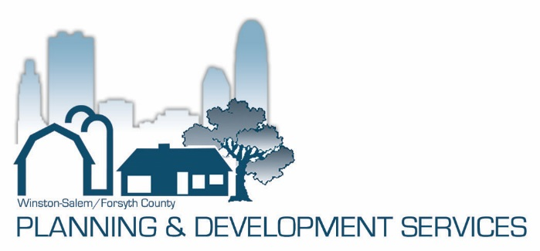

City of Winston-Salem University
Planning and Development Services
Review Questions—March 5, 2020

Please circle the correct answer:

- Which is not true about the Planning and Development Services Department?
- Assists the community and its decision makers in preparing for future growth and improvement.
- Administers the development regulations and building codes applicable in our community in a fair, consistent and efficient way.
- Serves Winston-Salem, Forsyth County and other municipalities in Forsyth County.
- Has included Planning and Inspections since the City-County Planning Board was authorized by State enabling legislation in 1948.

- The Planning and Development Services Department provides professional support to:
- City-County Planning Board
- Winston-Salem, Forsyth County, Lewisville, Walkertown and Clemmons Boards of Adjustment
- Historic Resources Commission
- Community Appearance Commission
- All of the above

- Which board(s) consider(s) the granting of variances and special use permits in the City of Winston-Salem?
- City-County Planning Board
- Forsyth County Board of Adjustment
- Winston-Salem Zoning Board of Adjustment
- Historic Resources Commission
- All of the above

- Which board(s) makes recommendations to the Winston-Salem City Council and Board of County Commissioners regarding proposed rezonings?
- City-County Planning Board
- Forsyth County Zoning Board of Adjustment
- Winston-Salem Zoning Board of Adjustment
- Historic Resources Commission
- All of the above

- The UDO ClearCode includes regulations related to:
- Zoning
- Parking
- Signs
- Landscaping in parking lots and between uses
- All of the above

- Which Inspections Division program is mandated by the State of North Carolina to be enforced by local governments?
- Building Code Enforcement
- Sign Enforcement
- Zoning Enforcement

- Building codes enforced throughout Forsyth County are adopted and amended by the Winston-Salem City Council and the Forsyth County Board of Commissioners.
- True
- False

- The installation and location of a new building must comply with applicable requirements of which regulation(s)?
- The NC Building Code
- The Unified Development Ordinances (UDO)
- Both a) & b)

9. The Zoning Enforcement section of Planning & Development Services is responsible for the enforcement of violations such as tall grass, trash, and abandoned vehicles.
a) True
b) False

10. Which of the following statements is true about Legacy 2030?
a) Legacy 2030 was adopted by all nine jurisdictions in Forsyth County.
b) It establishes polices that help to guide growth in Forsyth County.
c) The Growth Management Plan is an important tool in helping to guide growth in a responsible manner.
d) All of the above

